Event capture
graphical user interface

Patch Installation Guide



Software Version 2.0
Patch EC*2*116
December 2012

Department of Veterans Affairs
Office of Information and Technology (OIT)
Product Development

Table of Contents

1 Introduction 1
1.1 Purpose 1
1.2 Scope 1
1.3 Acronyms 1
2 Install Requirements 2
2.1 Package Integration 2
2.2 Server Requirements 2
2.3 Client Requirements 2
3 Client Installation 3
3.1 RPC Broker 3
3.2 Command Line Parameters 3
3.3 ECS GUI Client Installation 4

Introduction

Purpose
The purpose of this Installation Guide is to provide details on the installation of Event Capture System (ECS) software Graphical User Interface (GUI) for patch EC*2.0*116. The intended audience includes Technical Services, National Veterans Health Information Systems and technology Architecture (VistA) Support and Software Quality Assurance.

Scope
Patch EC*2.0*116 is an informational patch that requires an update to the GUI only. A Kernel Installation & Distribution System (KIDS) build is not required for this patch.

Acronyms
Term | Definition
DD | Data Definitions
DSS | Decision Support System
DSO | Decision Support Office
EC | Event Capture
ECS | Event Capture System
GP | GUI Parameter
GUI | Graphical User Interface
KIDS | Kernel Installation & Distribution System
TM | Tool Menu
VA | Department of Veterans Affairs
VistA | Veterans Health Information Systems and Technology Architecture

Install Requirements

Package Integration
The following package versions (or higher) must be installed prior to loading this patch of EC:

Kernel 8.0
Toolkit 7.3
Event Capture 2.0
RPC Broker 1.1
MailMan 8.0
VA FileMan 22.0

Server Requirements
Any site not currently running the ECS application and wishing to install ECS GUI must install all previous EC patches. For details on how to install the previous EC patches, please refer to the corresponding patch descriptions and EC 2.0 Installation Guide.

Each user will also need to have the option EC GUI CONTEXT added to their secondary menu.

Client Requirements
ECS GUI may be run in a test environment before installation, but it is not necessary. EC runs on the standard hardware platforms used by Department of Veterans Affairs (VA) Healthcare facilities. These systems consist of VMS/Cache or Linux/Cache platforms.

To run this Delphi-based application, the following is recommended:

- Intel Pentium 90 or higher (P166 recommended)
- Microsoft Windows 98 or NT 4.0 with Service Pack 3 or later
- Memory: 32MB of RAM (64MB or more recommended)
- Hard disk space: 6MB
- VGA or higher resolution monitor
- Mouse or other pointing device
- Networks supported: Any Microsoft Windows 98, or Windows NT or higher compatible network

Note: Software that is wholly a local development effort (such as BA Loader, etc.) may not be compatible with Event Capture. Please verify compatibility prior to installation.

Client Installation

RPC Broker
The assumption is made that your PC has the required RPC Broker Client Workstation set up. If this is not the case, you should first install this software. The installation is beyond the scope of this Installation Guide, but the RPC Broker files and installation instructions can be found on the VAs RPC Broker web page. These files must be installed before running the ECS GUI application.

Command Line Parameters
Note: The parameters may be in any order. Parameters S and P are a set, i.e., they must both be present or they will be ignored.

Parameter | Example (Default) | Description
S= | S=BrokerServer | The name of the ECS GUI BrokerServer as defined in the Host file.  The default is ‘BrokerServer’
P= | P=nnnn | The ServerPort used by the ECS GUI BrokerServer.  Example P=9200

ECS GUI Client Installation
Follow these instructions to install the ECS GUI:

- Save the .exe file to one of your network drives. Do not save it directly to the desktop.
- Double-click on SETUP.EXE. The InstallShield Wizard launches.

Example: Preparing to Install Progression Monitor

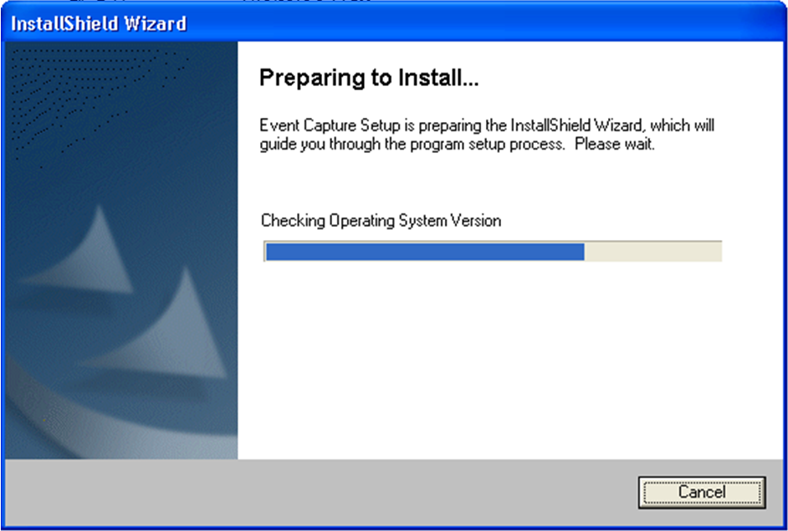

- When the Welcome to the InstallShield Wizard for Event Capture screen displays, click Next.

Example: Welcome to the InstallShield Wizard for Event Capture Screen

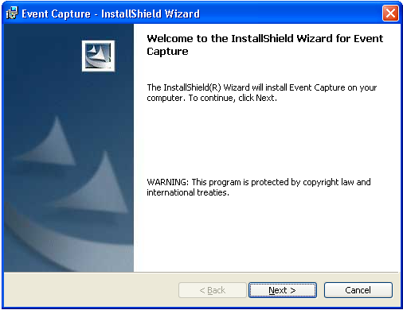

- On the Destination Folder screen, click Next to install to the default destination folder (C:\Program Files\VISTA\EC\). To install to a different folder, click Change.
Note: For WIN7, the installation creates the file in the ‘Program Files (x86)’ directory.

Example: Creating Destination Folder

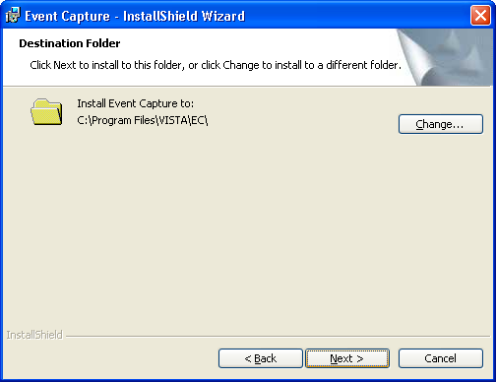

- Review the information on the Ready to Install the Program screen. If the information is correct, click Install. If changes are necessary, click Back.

Example: Ready to Install the Program for Event Capture

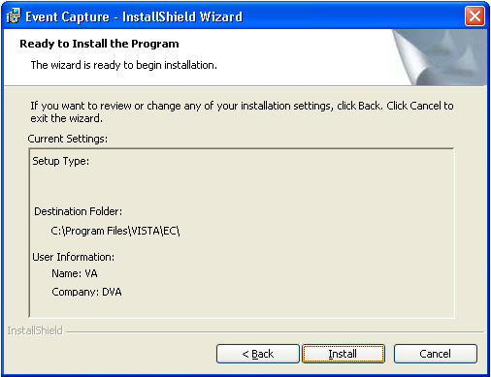

- The Installing Event Capture screen appears and shows the status of the install.

Example: Installing Event Capture Status screen

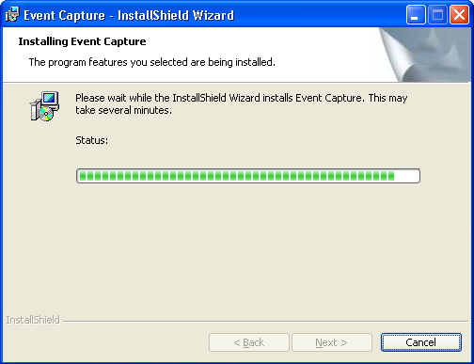

- The Install Wizard Completed screen appears when the install is complete. Click Finish. Event Capture will now be installed.

Example: Installing Event Capture Status screen

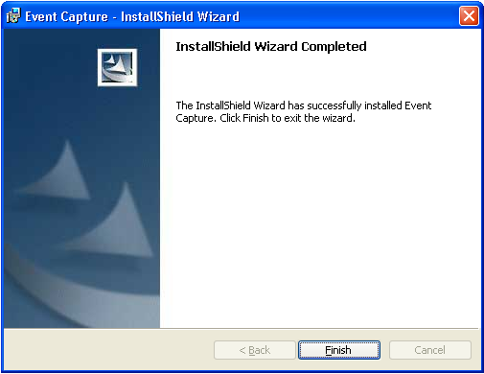

- Go to the Start menu and select All Programs. Select Event Capture and then ECS GUI.

Example: Accessing ECS GUI via Start Menu

- Right-click on the ECS GUI and select Properties.

Example: Selecting Properties



- After the file name (listed in Target), you will need to add the server (example: s=XXXX) and port (example: p=XXXX).
Note: Be sure to add one space before you add the server and port information.
Note: The server and port can be provided by your particular site. Without this information, Event Capture will not be able to run.

Example: Adding Server and Port to the Target Field



- Click Apply.
- The setup is complete. To create a shortcut on your desktop, right-click on the ECS GUI icon. Select Send To and the Desktop (create shortcut).



- Note for WIN7 users: For ECS GUI to operate the side scroll bar, the menu boxes may have to be in CLASSIC MODE. The WIN7 default puts framing around the GUI box that prevents you from scrolling up/down on certain report displays.

This installation installs the GUI executable on the user’s workstation at location: C:\Program Files\VISTA\EC (unless another directory was specified on the “Choose Designation Location” screen). Using Windows or NT Explorer, go to the directory location of the executable (on the user’s workstation), create a Shortcut, and paste or copy it to the user’s Desktop for convenient access to the application.

If any prior versions of the applications exist on in the user’s directory location referenced above, these should be deleted.

